**Industrial Internship Report on**

**”Quiz game ”**

**Prepared by**

**[Geethika kotni]**

|  |
| --- |
| *Executive Summary* |
| This report provides details of the Industrial Internship provided by upskill Campus and The IoT Academy in collaboration with Industrial Partner UniConverge Technologies Pvt Ltd (UCT).  This internship was focused on a project/problem statement provided by UCT. We had to finish the project including the report in 6 weeks’ time.  My project was quiz game. The quiz game is a Python project that quizzes users on various topics. It reads questions and answers from a file or database, presents them to the user, and keeps track of their score.  This internship gave me a very good opportunity to get exposure to Industrial problems and design/implement solution for that. It was an overall great experience to have this internship. |

**TABLE OF CONTENTS**

1 Preface 4

2 Introduction 5

2.1 About UniConverge Technologies Pvt Ltd 5

2.2 About upskill Campus 10

2.3 Objective 12

2.4 Reference 12

2.5 Glossary 12

3 Problem Statement 14

4 Existing and Proposed solution 16

5 Proposed Design/ Model 17

5.1 High Level Diagram (if applicable) **Error! Bookmark not defined.**

6 Performance Test 19

6.1 Test Plan/ Test Cases 19

6.2 Test Procedure 19

6.3 Performance Outcome 20

7 My learnings 22

8 Future work scope 23

# Preface

The python project “quiz game “was developed over a span of 6 weeks, meeting the objectives of designing a user-friendly interface, implementing a data storage system, and tracking user scores. The project demonstrates the ability to create an interactive and engaging application using Python.

Internships are a great way to gain practical experience and further your career development.

My project was “QUIZ GAME “.

Description: The quiz game is a Python project that quizzes users on various topics. It reads questions and answers from a file or database, presents them to the user, and keeps track of their score.

Scope: The scope of this project involves designing a user interface to display questions and collect user answers, implementing a database or file system to store quiz data, and developing a scoring algorithm to track the user's progress and calculate their final score.

UCT provided me a free internship which helped to develop my skills in python programming language.

How Program was planned



I learnt a lot in this internship provided by UCT.

Thanks to all who have helped me directly or indirectly.

My message to my juniors is to develop their skill in different course of their interest and I suggest them to take internship provided by UCT.

# Introduction

## About UniConverge Technologies Pvt Ltd

A company established in 2013 and working in Digital Transformation domain and providing Industrial solutions with prime focus on sustainability and RoI.

For developing its products and solutions it is leveraging various**Cutting Edge Technologies e.g. Internet of Things (IoT), Cyber Security, Cloud computing (AWS, Azure), Machine Learning, Communication Technologies (4G/5G/LoRaWAN), Java Full Stack, Python, Front end**etc.



1. UCT IoT Platform **(****)**

**UCT Insight** is an IOT platform designed for quick deployment of IOT applications on the same time providing valuable “insight” for your process/business. It has been built in Java for backend and ReactJS for Front end. It has support for MySQL and various NoSql Databases.

* It enables device connectivity via industry standard IoT protocols - MQTT, CoAP, HTTP, Modbus TCP, OPC UA
* It supports both cloud and on-premises deployments.

It has features to  
• Build Your own dashboard  
• Analytics and Reporting  
• Alert and Notification  
• Integration with third party application(Power BI, SAP, ERP)  
• Rule Engine

 

1. **Smart Factory Platform (****)**

Factory watch is a platform for smart factory needs.

It provides Users/ Factory

* with a scalable solution for their Production and asset monitoring
* OEE and predictive maintenance solution scaling up to digital twin for your assets.
* to unleased the true potential of the data that their machines are generating and helps to identify the KPIs and also improve them.
* A modular architecture that allows users to choose the service that they what to start and then can scale to more complex solutions as per their demands.

Its unique SaaS model helps users to save time, cost and money.

 

1.  based Solution

UCT is one of the early adopters of LoRAWAN teschnology and providing solution in Agritech, Smart cities, Industrial Monitoring, Smart Street Light, Smart Water/ Gas/ Electricity metering solutions etc.

1. Predictive Maintenance

UCT is providing Industrial Machine health monitoring and Predictive maintenance solution leveraging Embedded system, Industrial IoT and Machine Learning Technologies by finding Remaining useful life time of various Machines used in production process.



## About upskill Campus (USC)

upskill Campus along with The IoT Academy and in association with Uniconverge technologies has facilitated the smooth execution of the complete internship process.

USC is a career development platform that delivers **personalized executive coaching** in a more affordable, scalable and measurable way.



Seeing need of upskilling in self paced manner along-with additional support services e.g. Internship, projects, interaction with Industry experts, Career growth Services

<https://www.upskillcampus.com/>

upSkill Campus aiming to upskill 1 million learners in next 5 year



## The IoT Academy

The IoT academy is EdTech Division of UCT that is running long executive certification programs in collaboration with EICT Academy, IITK, IITR and IITG in multiple domains.

## Objectives of this Internship program

The objective for this internship program was to

 ☛ get practical experience of working in the industry.

 ☛ to solve real world problems.

 ☛ to have improved job prospects.

 ☛ to have Improved understanding of our field and its applications.

 ☛ to have Personal growth like better communication and problem solving.

## Reference

[1] Modules provided by upskill campus.

[2] Reports provided during the week.

## Glossary

|  |  |
| --- | --- |
| Terms | Acronym |
| Vscode | Visual studio code |
| UCT | Uniconverge technologies |

# Problem Statement

QUIZ GAME: The quiz game is a Python project that quizzes users on various topics. It reads questions and answers from a file or database, presents them to the user, and keeps track of their score.

questions = ("what skills are required to become data scientist?",

"what is the official language of the Indian state of Andrapradesh? ",

"which indian state is known as land of five rivers ? : ",

"in which year project tiger was launched by the government of india?: ")

options = (("A.python", "B.powerbi", "C.communication", "D.all of the above"),

("A.hindi", "B.english", "C.tamil", "D.telugu"),

("A.punjab", "B.andrapradesh", "C.himachalpradesh", "D.gujarat"

("A.1963", "B.1973", "C.1977", "D.1967d"))

answers = ("D", "D", "A", "B")

guesses = []

score = 0

question_number = 0

for question in questions:

print("----------------")

print(question)

for option in options[question_number]:

print(option)

guess = input("Enter the answres: ").upper()

guesses.append(guess)

if guess == answers[question_number]:

score += 1

print("Right answers")

else:

print("Incorrect!")

print(f"{answers[question_number]} is the right answers")

question_number += 1

print("----------")

print("Result")

print("---------")

print("answers: ", end=" ")

for ans in answers:

print(ans, end=" ")

print()

print("guesses: ",end=" ")

for guess in guesses:

print(guess, end=" ")

print()

score = int(score/len(questions) * 100)

print(f"your score is: {score}% ")

# Existing and Proposed solution

Uniconverge technologies in collaboration with Upskill campus and IOT Academy provided me opportunity to improve my skills in python programming language. I have utilized the opportunity and developed a code for quiz game project. I developed this code using visual studio code. I have shared my code of quiz game project and report on this internship in my GitHub account. links are provided below:

## Code submission (GitHub link):

## https://github.com/Geethikakotni

## Report submission (GitHub link):

## https://github.com/Geethikakotni

# Proposed Design/ Model

## Code:

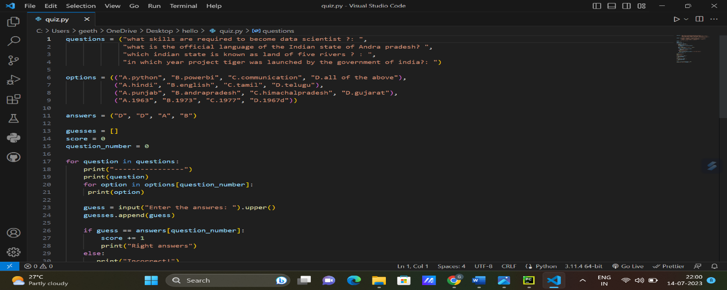

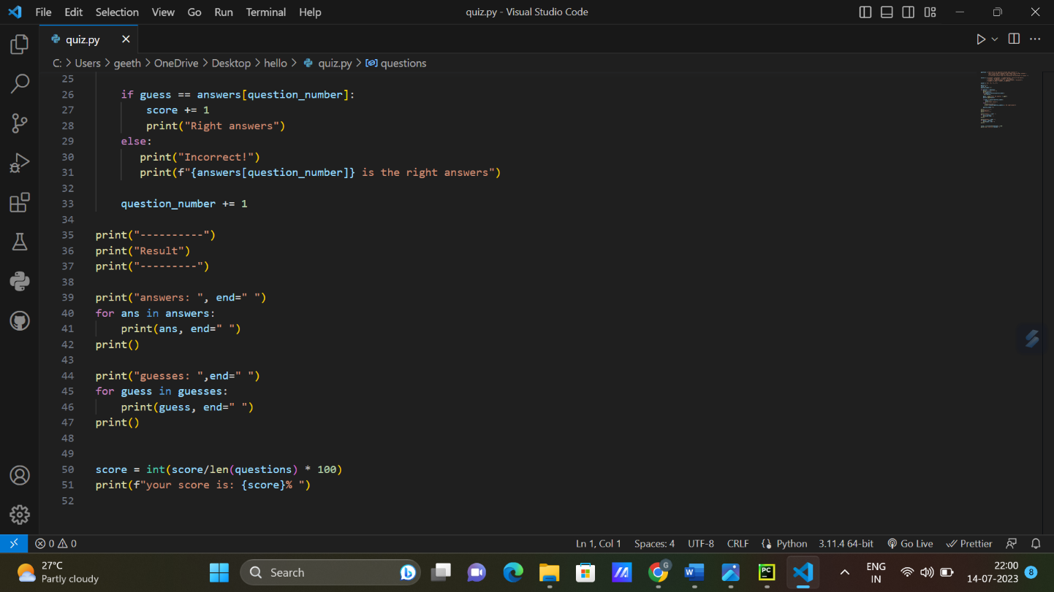

Figure 1: HIGH LEVEL DIAGRAM OF THE SYSTE

# Performance Test:

This work is meant for real industries rather than just academic projects because it offer several distinct advantages and opportunities for the students.

It allows students to gain practical experience and apply their academic knowledge in real-world settings.

By working in a real industry, interns can understand how theories and concepts are implemented, see the day-to-day operations, and tackle actual challenges faced by professionals in their field.

Real industry internships provide an excellent platform for skill development.

Interns have the opportunity to acquire and enhance specific technical skills, industry-specific knowledge, and transferable skills like teamwork, communication, problem-solving, and time management.

These skills are often crucial for success in the workplace and cannot be fully developed through academic projects alone.

They can learn from feedback, challenges, and successes, ultimately shaping their career aspirations and goals.

## Test Plan/ Test Cases:

To gain the practical knowledge of python programming language.

To have Improved understanding of our field and its applications.

 To have Personal growth like better communication and problem solving.

Design a user-friendly interface to display questions and collect user answers.

Implement a database or file system to store quiz data.

Develop a scoring algorithm to track the user's progress and calculate their final score.

## Test Procedure:

Week 1:

- Conducted initial research on quiz game mechanics and user interface design.

Week 2-3:

- Implemented the user interface for displaying questions and collecting user answers.

- Developed a data storage solution using a file or database system

Week 4-5:

- Designed and implemented the scoring algorithm to track user progress and calculate scores.

Week 6:

- Conducted thorough testing and debugging of the quiz game.

- Fine-tuned the user interface and resolved any remaining issues.

- Finalized the project documentation and prepared for deployment.

## Performance Outcome:

The quiz game project was successfully implemented and tested.

- Users can now enjoy a dynamic quiz experience with varying questions and topics.

- The project can serve as a foundation for further enhancements, such as multiplayer mode, online leaderboards, or more advanced question types.

- The project documentation provides a detailed overview of the system architecture, functionality, and instructions for future developers or maintainers.

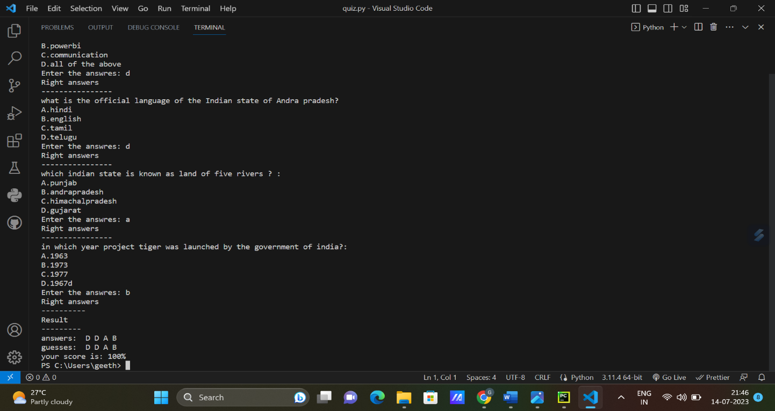

# My learnings:

During my internship program, I had the opportunity to gain valuable insights and develop various skills that have contributed to my professional growth. Here are the key learnings from my internship:

Technical Skills: I acquired and honed several technical skills related to my field of study through hands-on experience and guidance from my mentors, I gained proficiency in python

Project Management: I had the chance to be involved in diverse projects, allowing me to develop strong project management skills. I learned how to prioritize tasks, set realistic deadlines, and effectively collaborate with team members to achieve project goals.

Communication and Collaboration: Working closely with a diverse team, I improved my communication and collaboration abilities. I learned how to effectively convey ideas, actively listen, and provide constructive feedback. Additionally, I gained experience in working with cross-functional teams, adapting to different work styles, and collaborating towards shared objectives.

Problem-Solving: The internship provided numerous opportunities to tackle challenging problems. I developed critical thinking and problem-solving skills by analyzing issues, brainstorming creative solutions, and implementing strategies to overcome obstacles. I learned to approach problems from multiple perspectives and leverage available resources to reach optimal outcomes.

Overall, provided a rich learning experience that allowed me to apply theoretical knowledge in a practical setting.

.

# Future work scope:

I would like to continue my learning even after the completion of my internship. Due to time limit here, I could not able to complete whole module provided.so I will complete those modules and improve my technical and practical knowledge.

The quiz game project was successfully implemented and tested.

- Users can now enjoy a dynamic quiz experience with varying questions and topics.

- The project can serve as a foundation for further enhancements, such as multiplayer mode, online leaderboards, or more advanced question types.

- The project documentation provides a detailed overview of the system architecture, functionality, and instructions for future developers or maintainers.